VP of HR Job Description [Template]

The position of Vice President of Human Resources (HR) is crucial to any mid- to large-sized organization. The VP of HR is responsible for not only ensuring the success of the human resources department, but of the entire company’s hiring, onboarding, retention, compliance, and training programs. This is a position that requires many years of experience and education at the highest level, which means that writing a job description for the VP of HR can be difficult. Your job postings are part of your company’s talent brand, while job descriptions, like the one you see below, are meant for your career site and for links in job postings to give your prospective VP of HR candidates more detailed information. Job descriptions must contain all the important information about the role and should be optimized with keywords that will drive traffic to the listing on your career site. We’ve put together a basic set of guidelines on how to write an effective job description posting and template.

Vice President of Human Resources Job Duties and Salary
The VP of HR is always a salaried position. Depending on the size of the organization, the vice president of human resources often reports directly to the CEO or COO of an organization, Although sometimes the CHRO or chief human resource officer has this distinction. Depending on the structure and size of the organization, the VP of HR works with the executive team to discuss business objectives. They view financial documents and work to understand how the focused programs and services they offer the organization drive revenue. The VP of HR works to integrate people into the full scope of business operations, evaluating how the impact of human capital benefits the overall organization. This position is heavily focused on business metrics, reporting, and analytics directly in contrast to the administrative roots of the industry. This is an exempt level position and often a key decision maker at the company. This position is sometimes called the VP of People.

GRAPHIC -
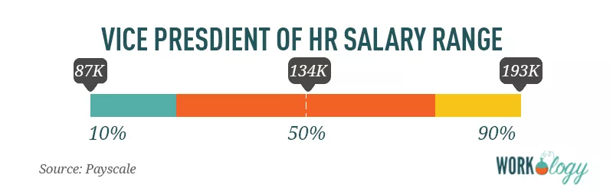
[Source: Payscale]
The average pay for a Vice President of HR is $134,000 per year. Those in the 90th percentile make $193,000 per year, and those in the 10th percentile have an income of $87,000.

Vice President of Human Resources Job Description
Company ABC is a staffing agency in the U.S. known for our creative, marketing, and executive talent placement. We place permanent and contract-to-hire professionals in hard-to-fill positions for organizations from startups to the Fortune 50.

We’re looking for an experienced Vice President of Human Resources for an internal role in at our corporate headquarters in the beautiful Duluth, Minnesota. This is a salaried position, full-time, onsite, and responsible for organizational development, recruitment and staffing, compensation and benefits packages, employment law, human resources leadership, as well as employee relations for our workforce.

A typical day as VP of HR includes:
- Develop and drive organizational effectiveness and support the president or CEO on all major initiatives.
- Management, leadership, and direction for the entire HR department, as well as outside consultants such as recruitment specialists.
- Facilitating and providing guidance to management teams in HR matters, directing staff on HR functions, and developing, interpreting, and implementing policies and procedures according to federal and state laws and regulations.
- Avoiding litigation and other potential losses by overseeing participation in Equal Employment Opportunity, Americans with Disabilities Act, Family and Medical Leave Act and other federal and state regulations.
- Establishing short- and long-term goals, budgeting for HR expenses, and networking with outside peers and organizations when needed to achieve goals.

What you’ll like most about working in Human Resources at Company ABC:
- We take great pride in offering our workforce the best benefits and compensation packages in our industry, and we think you will too.
- Everyone at ABC Company contributes to the development of programs, regardless of role. Your input will not only be heard; it will be encouraged.
- As a leader of our HR team, you’ll be driving our company culture and what makes us an amazing place to work.

We’re looking for candidates who:
- Have a Master’s Degree in Human Resources Development and Administration or equivalent degrees in marketing, business, or related field.
- Have SHRM PHR certification.
- Have 8-10+ years of experience gained through increasingly responsible management positions within Human Resources.
- Are experienced with employment law and compliance on state and federal levels.
- Have specialized training in organizational planning, compensation, and preventive labor relations.

Preferred qualifications:
- Experience working with more than two divisions within the same organization.
- Proven experience developing, testing and analyzing company human resources programs.
- Direct experience in People Operations and workforce planning.

What we offer our employees:
- A competitive compensation and benefits package, plus performance-based bonus incentives. Our corporate HQ offers on-site concierge services for dry cleaning, laundry and grocery shopping delivery, as well as catered lunches and a stocked snack and drink pantry. We’re a culture that thrives on training and development and offer several ongoing management training and leadership programs.

About COMPANY:
With three decades in the staffing industry, Company ABC has become a standout among its peers as a talent-driven, creativity-focused agency. Our employees and contract workforce have ranked us in the top 50 Best Places to Work by Glassdoor every year since 2002. Talent is what makes Company ABC successful, and we’re proud of our ability to deliver top talent to hundreds of well-known organizations for their unique marketing and creative staffing needs.

<EEOC statement>
Equal Opportunity Employer/Protected Veterans/Individuals with Disabilities. Please view Equal Employment Opportunity Posters provided by OFCCP here. The employee will not discharge or in any other manner discriminate against employees or applicants because they have inquired about, discussed, or disclosed their own pay or the pay of another employee or applicant. However, employees who have access to the compensation information of other employees or applicants as a part of their essential job functions cannot disclose the pay of other employees or applicants to individuals who do not otherwise have access to compensation information, unless the disclosure is (a) in response to a formal complaint or charge, (b) in furtherance of an investigation, proceeding, hearing, or action, including an investigation conducted by the employer, or (c) consistent with the contractor’s legal duty to furnish information.

Like what you see? Check out the rest of our human resources job titles, HR salary information, and templates.

