Recruiting Director Job Description Template

The position of Recruiting Director is a leadership role, and has a variety of responsibilities making it unique for each organization. Writing job descriptions, including one for a Recruiting Director is a challenge. A job posting is part of talent brand marketing while job descriptions, like the one you see below, are meant for your career site and for links in job postings to give your prospective Recruiting Director candidates more detailed information. Job descriptions must contain all the important information about the role and should be optimized with keywords that will drive traffic to the listing on your career site. We’ve put together a basic set of guidelines on how to write an effective job description posting and template.

Recruiting Director Job Duties and Salary
The Recruiting Director is responsible for the hiring of the entire head of recruiting which is also often referred to as talent acquisition, or talent attraction in some organizations. The Recruiting Director often reports to the VP of HR and serves as the senior leader focused on the hiring and recruiting process. This individual is the department decision maker responsible for budgeting, allocation, and strategy planning to interface with senior leadership on the subject of talent acquisition and recruitment. Recruiting Directors are responsible for setting guidelines for the company's hiring policies and overseeing a team of employees. Strong interpersonal and communication skills are important in this position. This position is an exempt level position.

GRAPHIC
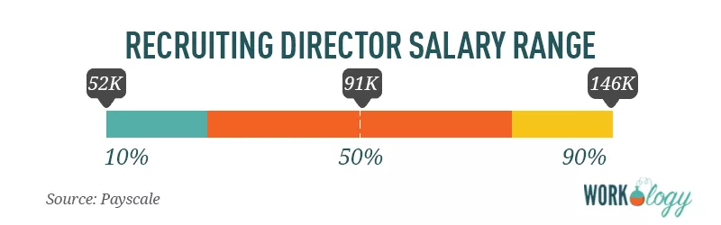
[Source: Payscale]
The average pay for a Recruiting Director is 91,000 per year. Those in the 90th percentile make $146,000 per year, and those in the 10th percentile have an income of $52,000.

Recruiting Director Job Description
Company ABC is a staffing agency in the U.S. known for our creative, marketing, and executive talent placement. We place permanent and contract-to-hire professionals in hard-to-fill positions for organizations from startups to the Fortune 500.

We’re looking for an exceptional Recruiting Director for an internal role in human resources at our corporate headquarters in the beautiful Duluth, Minnesota. This is a salaried position, full-time, onsite, and responsible for recruiting and retention strategies as well as diversity and inclusion, accessibility, and development programs for our workforce.

A typical day as Recruiting Director includes:
- Produce and deliver reports and data related to the company’s talent pool and current employees.
- Develop and execute recruiting and diversity strategies as well as attrition and retention strategies.
- Collaborate with leadership on team performance, account management, and service outcomes.
- Working face-to-face with employees to gather information and assess compensation and benefit requirements.
- Communicate frequently with departmental and executive stakeholders to understand the unique needs of our talent pool.

What you’ll like most about working in Human Resources at Company ABC:
- We take great pride in offering our contract workforce the best benefits and compensation packages in our industry, and we think you will too.
- Everyone at ABC Company contributes to the development of programs, regardless of role. Your input will not only be heard; it will be encouraged.
- As a member of our HR team, you’ll be driving our company culture and what makes us an amazing place to work.

We’re looking for candidates who:
Have a bachelor’s degree in marketing, HR, or related field.
Have Recruiting or other recruitment certification.
Have 5+ years of experience working in a talent acquisition and recruiting leader role with proven success metrics.
Experience leading a talent acquisition team of 5-10 team members and contractors.
Proficient with Microsoft Office and other administrative software to produce and deliver reports and data.
Experience managing, budgeting, planning, and negotiation recruitment vendor and technology agreements and implementations.
Experience with workplace accessibility, on and offline.

Preferred qualifications:
- Data analytics and management experience is a plus.
- Previous experience in an HR leadership role is preferred.
- Proven experience developing, testing and analyzing employee retention and diversity programs.

What we offer our employees:
- A competitive compensation and benefits package, plus performance-based bonus incentives. Our corporate HQ offers on-site concierge services for dry cleaning, laundry and grocery shopping delivery, as well as catered lunches and a stocked snack and drink pantry. We’re a culture that thrives on training and development and offers several ongoing management training and leadership programs.

About COMPANY:
With three decades in the staffing industry, Company ABC has become a standout among its peers as a talent-driven, creativity-focused agency. Our employees and contract workforce have ranked us in the top 50 Best Places to Work by Glassdoor every year since 2002. Talent is what makes Company ABC successful, and we’re proud of our ability to deliver top talent to hundreds of well-known organizations for their unique marketing and creative staffing needs.

<EEOC statement>
Equal Opportunity Employer/Protected Veterans/Individuals with Disabilities. Please view Equal Employment Opportunity Posters provided by OFCCP here. The employee will not discharge or in any other manner discriminate against employees or applicants because they have inquired about, discussed, or disclosed their own pay or the pay of another employee or applicant. However, employees who have access to the compensation information of other employees or applicants as a part of their essential job functions cannot disclose the pay of other employees or applicants to individuals who do not otherwise have access to compensation information, unless the disclosure is (a) in response to a formal complaint or charge, (b) in furtherance of an investigation, proceeding, hearing, or action, including an investigation conducted by the employer, or (c) consistent with the contractor’s legal duty to furnish information.

Like what you see? Check out the rest of our human resources job titles, HR salary information, and templates.

