HR Sourcer Job Description Template

The position of HR Sourcer, also called Talent Sourcer and Technical Sourcer, has a variety of iterations depending on the needs of your company, which make this role very unique for each organization. Writing job descriptions, including ones for a Talent Sourcer or HR Sourcer, is a challenge. A job posting is part of talent brand marketing while job descriptions, like the one you see below, are meant for your career site and for links in job postings to give your prospective HR Sourcer job seeker more detailed information. Job descriptions must contain all the important information about the role and should be optimized with keywords that will drive traffic to the listing on your career site. We’ve put together a basic set of guidelines on how to write an effective job description posting and template.

Sourcer Job Duties and Salary
A sourcer is someone who searches out and finds candidates for often highly technical, specialized, and hard-to-fill roles within an organization by building a candidate funnel. This is why the title for this positions has evolved from simply “sourcer” to “technical sourcer.” Sourcing is now predominantly accomplished by using the internet to search, source, and locate candidates, but can also be done using phone sourcing or other methods. Depending on the size of the organization and industry, this role might serve in phone screening or an initial qualifying call with candidates, but it depends on the larger organization and department. This is often a non-exempt role and commonly a contract position.

GRAPHIC
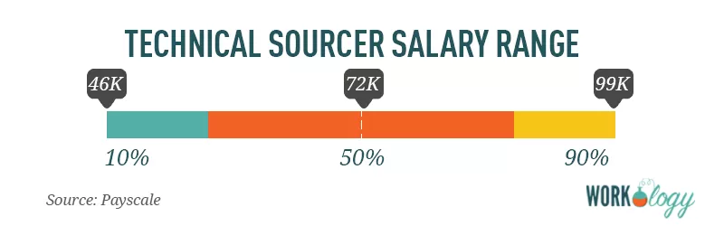
[Source: Payscale]
The average pay for a Technical Sourcer is $72,000 per year. Those in the 90th percentile make $99,000 per year, and those in the 10th percentile have an income of $46,000.

HR Sourcer Job Description
Company ABC is a staffing agency in the U.S. known for our creative, marketing, and executive talent placement. We place permanent and contract-to-hire professionals in hard-to-fill positions for organizations from startups to the Fortune 50.

We’re looking for an exceptional HR Sourcer for a role in human resources at our corporate headquarters in the beautiful Duluth, Minnesota. This is a salaried position, full-time, onsite, and responsible for candidate sourcing and applicant screening as well as building a talent funnel and candidate engagement for open positions at our company.

A typical day as HR Sourcer includes:
- Recruiting and screening candidates for current and future positions.
- Develop, test, and track recruitment strategies to create an effective sourcing plan for top talent.
- Engage and activate passive candidates through recruiting, best practices, and programs.
- Build relationships with candidate communities to maintain a network of potential candidates and nurture a pipeline of potential candidates.
- Communicate frequently with departmental and executive stakeholders to understand the needs of our hiring managers.

What you’ll like most about working in Human Resources at Company ABC:
- We take great pride in offering our workforce the best benefits and compensation packages in our industry, and we think you will too.
- Everyone at ABC Company contributes to the development of programs, regardless of role. Your input will not only be heard; it will be encouraged.
- As a member of our HR team, you’ll be driving our company culture and what makes us an amazing place to work.

We’re looking for candidates who:
- Have a bachelor’s degree in marketing, HR, or related field.
- Have 5+ years of experience working in the technical sourcing aspect of human resources with proven success metrics, either in-house or agency.
- Have strong technical skills using ATS and other HR software programs for candidate management.
- Possess exceptional written and verbal communication skills.

Preferred qualifications:
- SHRM PHR certification is a plus.
- Experience working in a highly regulated industry is a bonus.

What we offer our employees:
- A competitive compensation and benefits package, plus performance-based bonus incentives. Our corporate HQ offers on-site concierge services for dry cleaning, laundry and grocery shopping delivery, as well as catered lunches and a stocked snack and drinks pantry. We’re a culture that thrives on training and development and offers several ongoing management training and leadership programs.

About COMPANY:
With three decades in the staffing industry, Company ABC has become a standout among its peers as a talent-driven, creativity-focused agency. Our employees and contract workforce have ranked us in the top 50 Best Places to Work by Glassdoor every year since 2002. Talent is what makes Company ABC successful, and we’re proud of our ability to deliver top talent to hundreds of well-known organizations for their unique marketing and creative staffing needs.

<EEOC statement>
Equal Opportunity Employer/Protected Veterans/Individuals with Disabilities. Please view Equal Employment Opportunity Posters provided by OFCCP here. The employee will not discharge or in any other manner discriminate against employees or applicants because they have inquired about, discussed, or disclosed their own pay or the pay of another employee or applicant. However, employees who have access to the compensation information of other employees or applicants as a part of their essential job functions cannot disclose the pay of other employees or applicants to individuals who do not otherwise have access to compensation information, unless the disclosure is (a) in response to a formal complaint or charge, (b) in furtherance of an investigation, proceeding, hearing, or action, including an investigation conducted by the employer, or (c) consistent with the contractor’s legal duty to furnish information.

Like what you see? Check out the rest of our human resources job titles, HR salary information, and templates.

