HR Information Specialist Job Description Template

The position of Human Resource Information Specialist (HRIS) is vital to any company in today’s talent marketplace, as our reliance on technology within human resources increases exponentially. Because this can be a new position at many companies, it is imperative to identify the skills and traits, and outline them in your job description (for example, whether you need this position to be a leadership role or if you prefer a candidate who wishes to develop skills on the job). Your job posting is part of talent brand marketing while job descriptions, like the one you see below, are meant for your career site and for links in job postings to give your prospective HRIS candidates more detailed information. Job descriptions must contain all the important information about the role and should be optimized with keywords that will drive traffic to the listing on your career site. We’ve put together a basic set of guidelines on how to write an effective job description posting and template.

Human Resource Information Specialist (HRIS) Job Duties and Salary
An HRIS role within HR oversees and maintains the growing number of HR and recruiting technologies used by the department. The HRIS team member is familiar with recruiting and HR processes and responsibilities, but is highly technical working to maintain HR and recruiting technology systems. This role interfaces directly with the information technology or IT department (sometimes falling under its umbrella). As more companies add more technologies to existing departments, the importance of maintaining the tech, integrations, and basic administration is extremely important for HR’s future success with their organization. One of their main responsibilities includes giving technical guidance and direction to administrative, technical, and clerical staff on the operation and maintenance of the human resources data systems. This position is normally an exempt level or contract role within an organization.

GRAPHIC 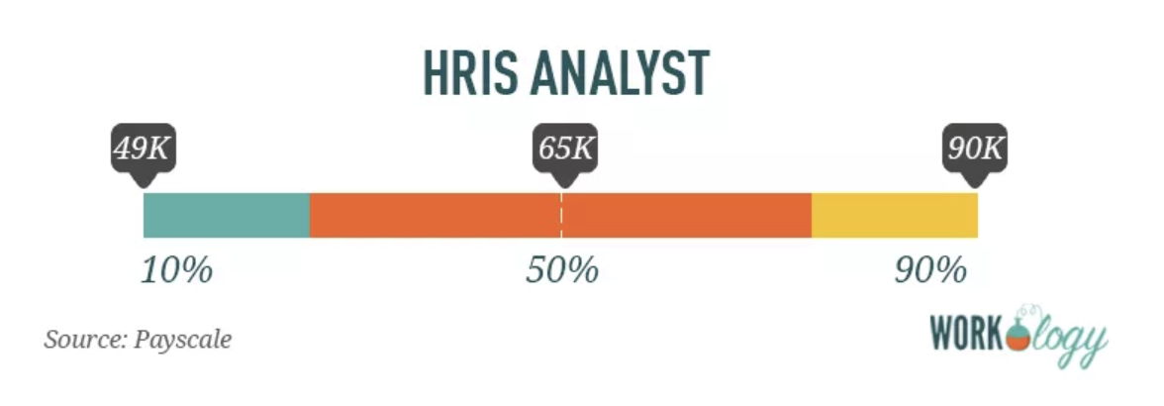

[Source: Payscale]
The average pay for a Human Resources Information Systems Specialist (HRIS) is $56,825 per year. Those in the 90th percentile make $84,000 a year, and those in the 10th percentile make $40,000 a year.

Human Resource Information Specialist (HRIS) Job Description
Company ABC is a staffing agency in the U.S. known for our creative, marketing, and executive talent placement. We place permanent and contract-to-hire professionals in hard-to-fill positions for organizations from startups to the Fortune 500.

We’re looking for an exceptional Human Resource Information Specialist (HRIS) for an internal role in human resources at our corporate headquarters in the beautiful Duluth, Minnesota. This is a salaried position, full-time, onsite, and responsible for HR technology and data systems as well as learning management design and systems training for our workforce.

A typical day as a Human Resource Information Specialist (HRIS) includes:
- Technical guidance and direction to administrative, technical, and clerical staff on the operation and maintenance of the human resources data systems.
- Providing on-the-job and formal training to human resource data system users using custom software and company applications.
- Prepare, maintain, and update employee data for the HR information system.
- Process and maintain periodic reports of employee record data and develop reports.
- Work closely with the HR team to administer and support all HR system technologies and enhancements that improve HR operational efficiency and effectiveness.
- Assists with projects such as data and workflow management, performance and compensation administration, learning management design, and training, and act as a liaison between Human Resources, Information Technology, Benefits, and Payroll to support HR projects.

What you’ll like most about working in Human Resources at Company ABC:
- We take great pride in offering our contract workforce the best benefits and compensation packages in our industry, and we think you will too.
- Everyone at ABC Company contributes to the development of programs, regardless of role. Your input will not only be heard; it will be encouraged.
- As a member of our HR team, you’ll be driving our company culture and what makes us an amazing place to work.

We’re looking for candidates who:
- Have a bachelor’s degree in IT, HR, computer science, or related field.
- The ability to troubleshoot technical issues, as well as develop and implement strategies to address problem areas with human resource technology.
- Have 5+ years of experience working on implementing and maintaining human resource information management systems, ATSs, and HROS.
- Possess a drive to improve current workflow and productivity via technology and a desire to learn and teach new technologies.

Preferred qualifications:
- Technology vendor management experience is a plus.
- Familiarity with the AGILE project workflow, scrum experience a plus.
- Candidates with leadership and industry certifications are preferred.
- Proven experience developing, testing, and analyzing human resources software.

What we offer our employees:
- A competitive compensation and benefits package, plus performance-based bonus incentives. Our corporate HQ offers on-site concierge services for dry cleaning, laundry, and grocery shopping delivery, as well as catered lunches and a stocked snack and drink pantry. We’re a culture that thrives on training and development and offers several ongoing management training and leadership programs.

About COMPANY:
With three decades in the staffing industry, Company ABC has become a standout among its peers as a talent-driven, creativity-focused agency. Our employees and contract workforce have ranked us in the top 50 Best Places to Work by Glassdoor every year since 2002. Talent is what makes Company ABC successful, and we’re proud of our ability to deliver top talent to hundreds of well-known organizations for their unique marketing and creative staffing needs.

<EEOC statement>
Equal Opportunity Employer/Protected Veterans/Individuals with Disabilities. Please view Equal Employment Opportunity Posters provided by OFCCP here. The employee will not discharge or in any other manner discriminate against employees or applicants because they have inquired about, discussed, or disclosed their own pay or the pay of another employee or applicant. However, employees who have access to the compensation information of other employees or applicants as a part of their essential job functions cannot disclose the pay of other employees or applicants to individuals who do not otherwise have access to compensation information, unless the disclosure is (a) in response to a formal complaint or charge, (b) in furtherance of an investigation, proceeding, hearing, or action, including an investigation conducted by the employer, or (c) consistent with the contractor’s legal duty to furnish information.

Like what you see? Check out the rest of our human resources job titles, HR salary information, and templates.

