HR Coordinator Job Description [Template]

A Human Resources (HR) Coordinator completes administrative duties for the human resources department of an organization. They assist HR managers with such a wide variety of tasks that larger HR departments often have multiple employees in this role. When writing a job description for an HR Coordinator, consider what area of your team this person will support, as well as whether or not you want to hire an experienced coordinator or someone with the administrative experience that can adapt to an HR role. Job descriptions must contain all the important information about the role, and should be optimized with keywords that will drive traffic to the listing on your career site. We’ve put together a basic set of guidelines on how to write an effective job description posting and template.

HR Coordinator Job Duties and Salary
A true administrative position, the HR Coordinator has responsibility for filing, maintaining reports, processing payroll and typically scheduling of interviews, as well as participating in the interview process. HR Coordinators might plan and organize events, develop email content for newsletters, and other inter-office communication within the department and the company. Their roles are focused on administration providing a valuable service to the organization in maintaining order and a system for everything. They are hourly non-exempt workers.

GRAPHIC
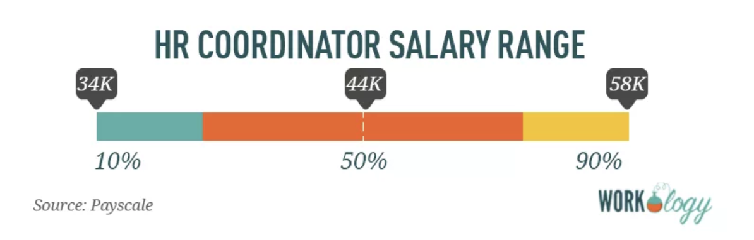
[Source: Payscale]

The average pay for an HR Coordinator is $18.32 per hour. As a salaried position, the average pay for an HR Coordinator is $44,353 per year. Those in the 90th percentile make $58,000 per year and those in the 10th percentile have an income of $34,000.

Human Resources (HR) Coordinator Job Description
We’re looking for an exceptional HR Coordinator for an internal role in human resources at our corporate headquarters in beautiful Scranton, Pennsylvania. This is an hourly position, full-time, onsite, and responsible for administrative, payroll, and reporting functions as well as recruitment and hiring of our sales talent candidates.

A typical day as an HR Coordinator includes:
- Answering employee requests and questions
- Assisting with new employee hiring processes
- Reconciling benefits statements
- Conducting audits of payroll, benefits, and other HR programs, and recommending corrective actions
- Assisting with the performance review and termination processes
- Assisting with the recruitment and interview processes

What you’ll like most about working in Human Resources at Dunder Mifflin:
- We take great pride in offering our workforce the best benefits and compensation packages in our industry, and we think you will too.
- Everyone at Dunder Mifflin contributes to the development of programs, regardless of role. Your input will not only be heard; it will be encouraged.
- As a member of our HR team, you’ll be driving our company culture and what makes us an amazing place to work.

We’re looking for candidates who:
- Have 2+ years of experience working in an administrative or office management role.
- Possess a natural talent and passion for customer support and service.
- Have solid communication skills and compassionate nature.
- Have a desire to learn and grow through on the job training and development.

Preferred qualifications:
- Customer support experience is a plus.
- Experience working with automated talent software programs or CMS is not required, but these candidates will be given preference.

What we offer our employees:
- A competitive compensation and benefits package, plus performance-based bonus incentives. Our corporate HQ offers on-site concierge services for dry cleaning, laundry, and grocery shopping delivery, as well as catered lunches and a stocked snack and drinkpantry. We’re a culture that thrives on training and development and offers several ongoing management training and leadership programs.

About COMPANY:
With over 20 years in sales and marketing talent recruiting, Dunder Mifflin Paper Company is globally recognized as the top recruiting firm for placing sales talent at companies around the world. Our customers are innovative Fortune 500 organizations who have come to expect the best salespeople, marketing personnel, and revenue analytics talent placement from our company. Not only do we place sales talent, but we’ve also made sales our business and our hiring app has been rated in the Top 10 Tech Recruiting Tools by Fast Company for the past three years.

<EEOC statement>
Equal Opportunity Employer/Protected Veterans/Individuals with Disabilities. Please view Equal Employment Opportunity Posters provided by OFCCP here. The employee will not discharge or in any other manner discriminate against employees or applicants because they have inquired about, discussed, or disclosed their own pay or the pay of another employee or applicant. However, employees who have access to the compensation information of other employees or applicants as a part of their essential job functions cannot disclose the pay of other employees or applicants to individuals who do not otherwise have access to compensation information, unless the disclosure is (a) in response to a formal complaint or charge, (b) in furtherance of an investigation, proceeding, hearing, or action, including an investigation conducted by the employer, or (c) consistent with the contractor’s legal duty to furnish information.

Like what you see? Check out the rest of our human resources job titles, HR salary information, and templates.

